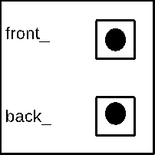Current Object



18







7



7



19



21



23



8



15



10



rhs





23



15



10



8

